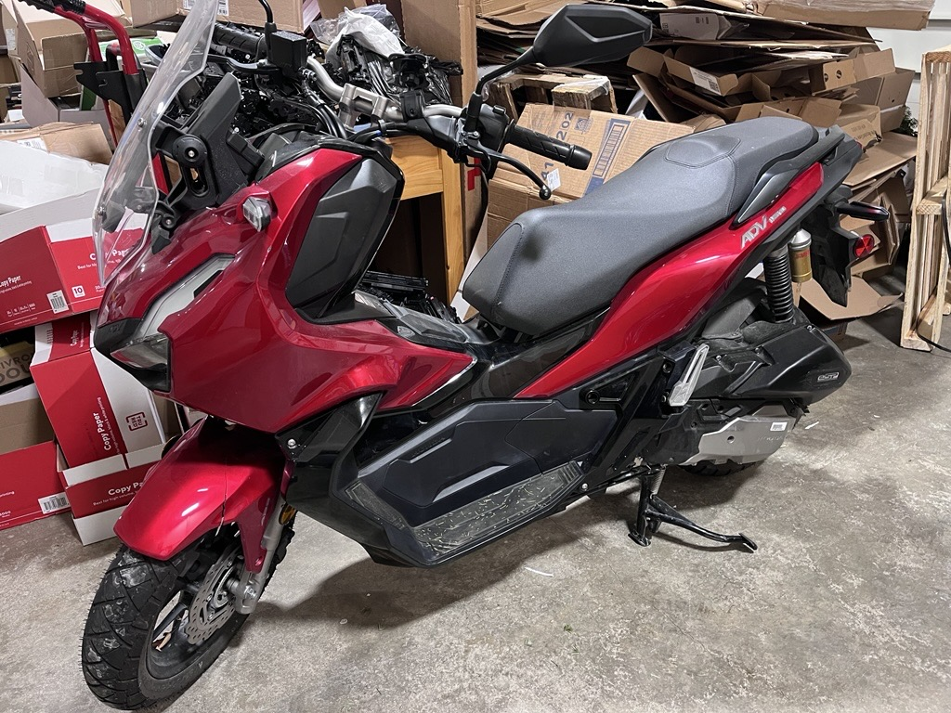

THE COUNTY FEDERAL CREDIT UNION

FOR SALE

2023 Honda ADV150AP - 649 Miles

Asking $3,200

Shown By Appointment Only – Serious Inquiries only, please

Interested buyers, please contact:
Text or leave a message at 207-768-8264

The County Federal Credit Union reserves the right to accept or reject any or all Offers submitted. Unit will be sold “As Is”

THE COUNTY FEDERAL CREDIT UNION
OFFER FORM

2023 Honda ADV150AP
Year Make Model

I certify that I have examined the above vehicle and herewith submit an offer in the amount of $____________. In making this offer, I understand the following terms and conditions of sale.

- All offers will be submitted to The County Federal Credit Union for review, and acceptance will be determined by the Credit Union.
- Any purchase is on an “AS IS” basis and under no circumstances are any warranties expressed or implied.
- Purchasers release The County Federal Credit Union from any liability for mechanical defects or any other defect in the motor vehicle.

This offer is submitted with the understanding that The County Federal Credit Union is under no obligation to accept it. It is further understood that the Credit Union may continue to solicit offers indefinitely until an offer in the amount acceptable to the Credit Union is received.

I understand that I may cancel this offer at any time

Name Phone #

Street Address

_______________________________________________________
City State Zip Code

_______________________________________________________
Signature Date

